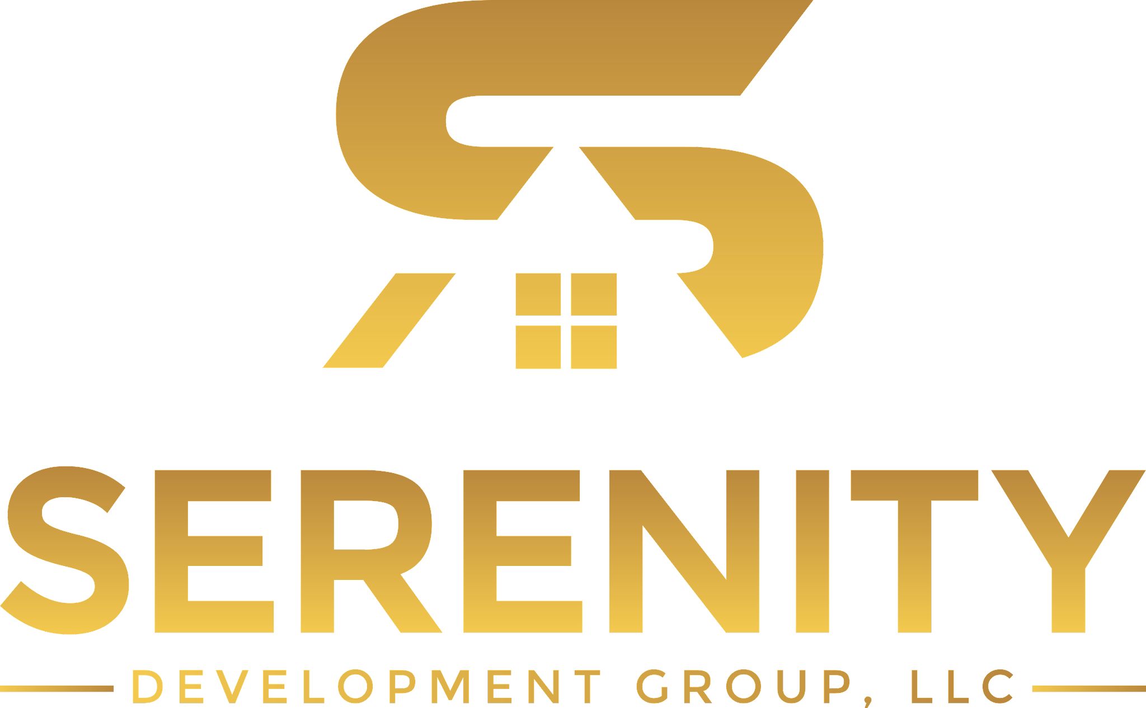

***BUILDING ONE RELATIONSHIP AT A TIME***

***100% WOMAN & MINORITY OWNED***

**CONSTRUCTION/ CONSTRUCTION MANAGEMENT**

Serenity Development Group (SDG) provides over 15 years of construction experience and the expertise to manage efforts ranging from multi-phase, multi-site construction projects to single construction projects. As a Construction Manager, SDG will guide the owner through the process and deliver the project to the expectations set out prior to the start. Acting as an extension of the owner’s staff, our team provides leadership and coordination to improve schedule performance, minimize cost overruns and ensure successful construction projects. SDG will prepare bid packages, review scopes of work, negotiate subcontracts and manage the work through closeout/turnover. The team at SDG plans for contingencies, considers alternatives and evaluates the next steps in order to plan for all possibilities. SDG will complete every project professionally and in a timely manner.

***CONSTRUCTION MANAGEMENT SERVICES INCLUDE:***

* Site Management (Site Logistics, Staging Plan, Safety Plan)
* Project Accounting
* Oversees Cost Control
* Coordination of Construction Contract Negotiation and Awards
* Project Scheduling
* Project Reporting
* Project Site Safety
* Coordination of Construction Activities
* Quality Assurance Management/Quality Control

We are a fully insured multifamily contractor. From infrastructure to landscaping, your multi-family development will run smoothly and efficiently under our control and leadership. We have completed developments for governments and private developers alike.

***CONSTRUCTION SERVICES INCLUDE but not limited to:***

* Commitment to Safety
* Quality Workmanship
* Large Support Staff
* Project 1st mentality
* Accurate & Timely Estimates
* Protect Your Best Interest
* Authentic & Genuine Business Approach

**SELECTIVE INTERIOR DEMOLITION**

Serenity Development Group utilizes techniques to safely and professionally meet the needs of any interior demolition project. We bring several years of experience combined with our detail oriented training to align to a client’s timetables and budgets to ensure the work is completed flawlessly and without interrupting daily operations.

The team at SDG is committed to offering the highest standards of service with the lowest impact to your environment.All employees on the worksites have the necessary training, PPE and applicable OSHA certifications. Serenity Development Group can perform this work in hospitals, industrial and commercial sites, government structures, military facilities and bridges.

INTERIOR SELECTIVE DEMOLITION SERVICES include but not limited to:

* Interior Strips/ Gut Outs
* Removal of Walls, Floors and Ceiling Finishes
* Removal of Interior & Exterior Building Components
* Exterior Facade/ Storefront Renovation
* Deconstruction & Dismantlement
* Complete Mechanical, Plumbing, Fire and Electrical System Demolition

**PRE & POST JANITORIAL SERVICES**

Serenity Development Group offers impeccable detailing and trust as our first priorities in our post construction janitorial services. Efficient cleaning starts with cleaning the worksite of any bulky items and large debris. Next, SDG's employees carefully go over each surface. We provide meticulous detailing to every project.

PRE & POST JANITORIAL SERVICES include but not limited to:

* Removal of drywall dust
* Floor & Tile Cleaning
* Bathroom Cleaning
* Interior Window Cleaning including Frames & Sills
* Dust Extraction & Removal from All Surfaces, Light Fixtures, Ductwork & Pipes
* Paint & Stain Removal
* Washing of all Surfaces including Floors & Walls
* Removal of Leftover Debris